1. **Agenda**:
   1. How to create dynamic responses using the **ResponseTemplateTransformer** concept?
2. The first thing we need to do is to inform WireMock that we’re going to use **ResponseTemplateTransformer.**
3. 
4. 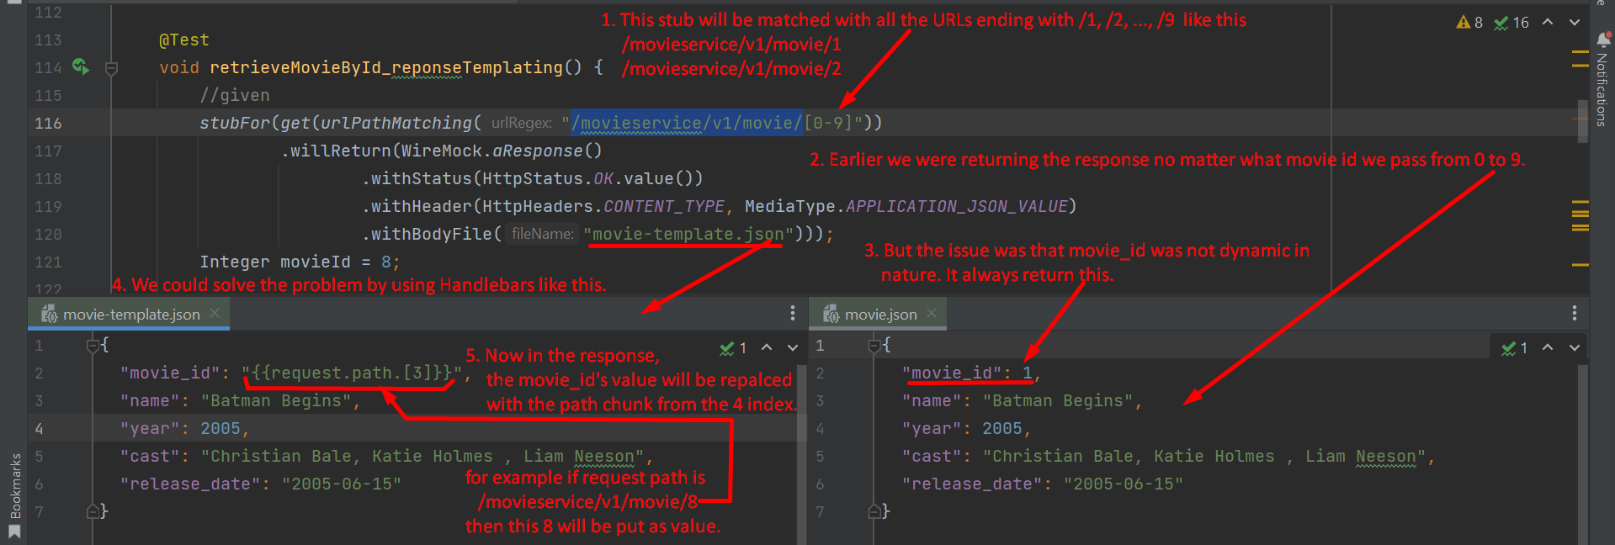  
   What we did above.
   1. Actually, first we made the URL a template with reg expression.
   2. Then we made the response as template using **Handlebars** 🡺 **{{**request.path.[3]**}}**
5. 